**DAILY ONLINE ACTIVITIES SUMMARY**

|  |  |  |  |  |  |  |  |
| --- | --- | --- | --- | --- | --- | --- | --- |
| **Date:** | **15-06-2020** | | | | **Name:** | **Varsha H Shetty** | |
| **Sem & Sec** | **VIII Semester & B Section** | | | | **USN:** | **4AL16CS117** | |
| **Online Test Summary** | | | | | | | |
| **Subject** | | **SMS** | | | | | |
| **Max. Marks** | | **60** | | **Score** | | **--** | |
| **Certification Course Summary** | | | | | | | |
| **Course** | **Introduction to Amazon Command Line Interface** | | | | | | |
| **Certificate Provider** | | | **Amazon Web Service** | **Duration** | | | **10 minutes** |
| **Coding Challenges** | | | | | | | |
| **Problem Statement: Write a program in for binary reversal** | | | | | | | |
| **Status: COMPLETED** | | | | | | | |
| **Uploaded the report in Github** | | | | **YES** | | | |
| **If yes Repository name** | | | | **Varsha-Shetty** | | | |
| **Uploaded the report in slack** | | | | **YES** | | | |

Online Test Details:

NIL

Certification Course :

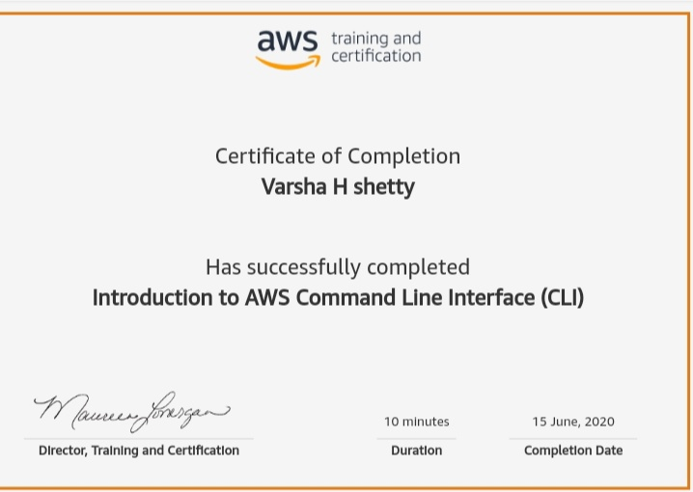

Coding Challenges Details:

|  |
| --- |
| **#include<stdio.h>**  **unsigned int reverseBits(unsigned int n)**  **{**  **unsigned int rev = 0;**  **while (n > 0)**  **{**  **rev <<= 1;**  **if (n & 1 == 1)**  **rev ^= 1;**  **n >>= 1;**  **}**  **return rev;**  **}**  **int main()**  **{**  **unsigned int n ;**  **printf("Enter the number :\n");**  **scanf("%d",&n);**  **printf("%d", reverseBits(n));**  **printf("\n");**  **return 0;**  **}** |
|  |
|  |
|  |
|  |
|  |
|  |
|  |
|  |
|  |
|  |
|  |
|  |
|  |
|  |
|  |
|  |
|  |
|  |
|  |
|  |
|  |
|  |
|  |
|  |
|  |
|  |
|  |
|  |
|  |
|  |
|  |
|  |
|  |
|  |
|  |
|  |
|  |
|  |
|  |
|  |
|  |
|  |
|  |
|  |
|  |
|  |
|  |
|  |
|  |
|  |
|  |
|  |
|  |

|  |  |
| --- | --- |
|  |  |